

Grocery Store Cashier Information System

Group 3

Names : Muhammad Nabiel Rayhan Falaah

Dennis Salomo Angelos Charisteas

Muhamad Alfabel

Class : 1CC2

CEP CCIT

FAKULTAS TEKNIK UNIVERSITAS INDONESIA

2022

**Developed by**

1. **Muhammad Nabiel Rayhan Falaah**
2. **Dennis Salomo Angelos Charisteas**
3. **Muhamad Alfabel**



**PROJECT ON**

*Grocery Store Cashier Information System*

**Grocery Store Cashier Information System**

Batch Code : 1CC2

Start Date : 18 October 2022   
End Date : 04 November 2022

Name of Faculty : Aisah Rini Susanti

Names of Developer :

1. Muhammad Nabiel Rayhan Falaah
2. Dennis Salomo Angelos Charisteas
3. Muhamad Alfabel

Date of Submission: 03 November 2022

**CERTIFICATE**

This is to certify that this report titled “Grocery Store Cashier Information System” embodies the original work done by Muhammad Nabiel Rayhan Falaah, Dennis Salomo Angelos Charisteas, and Muhamad Alfabel. Project in partial fulfillment of their course requirement at NIIT.

Coordinator:

Aisah Rini Susanti



**ACKNOWLEDGEMENT**

Sending our outmost gratitude to God for extending His mercy and giving His blessings so we could finish about developing Grocery Store Cashier Information System. We would like to thank everyone who contributed to the paper's completion as well as the several sources we consulted for the data and details on the project we’ve been working.

Hereby we hope that readers will be able to share their perspectives on how network technology is being used on universities. We are also conscious of the fact that we are flawed beings with flaws as the entire data couldn't be accurately described in this paper. We sincerely apologize for mistakes that may have occurred during the writing of this paper. Hence, we welcome reader feedback and suggestions to help us improve our writing in the future.

Depok, November 2022

Author

**SYSTEM ANALYSIS**

**System Summary**:

This project will be discussing about the system information of grocery store, especially the cashier machine information system, that will further be explained in the following flowchart and pseudocode, in order to deepen the understanding of grocery store cashier machine information system.

The to be discussed flowchart and pseudocode will be consisting of 2, the flowchart and the pseudocode, each part will be explaining about the whole process of cashier machine, in form of algorithm that will be visualised with both flowchart and pseudocode.

The objective of this topic is to have a better understanding about the grocery store information systems, especially the cashier machine information system through:

* Describing Information
* Describing System
* Describing Information system
* Describing Algorithm
* Describing the Flowchart of cashier machine system process
* Describing the Pseudocode of cashier machine system process
* Describing the dry run of the process

Each flowchart and pseudocode is consisting of 5 part of the program:  
.Main progam  
.Login  
.Add item  
.Checkout  
.Receipt

**FLOWCHART**

**System Process**: Main program

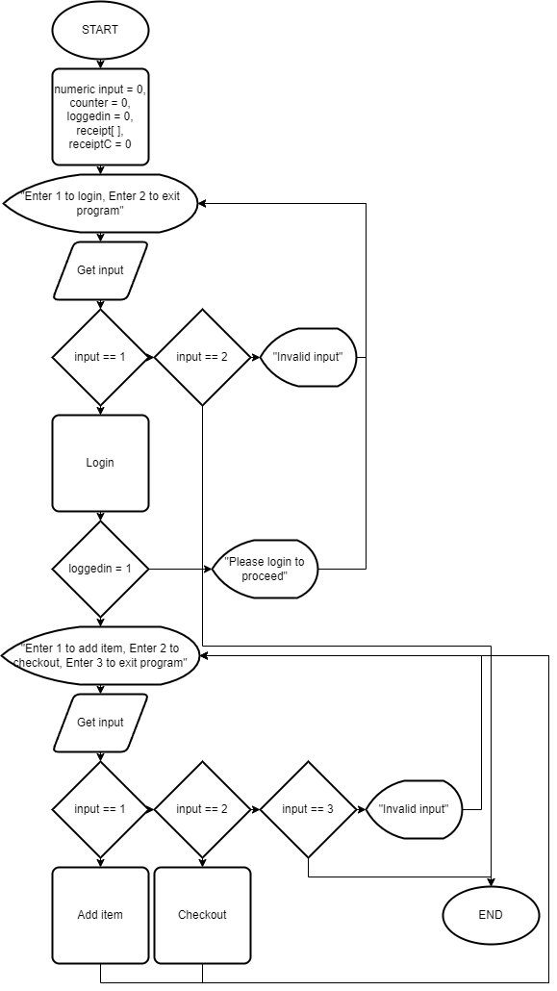

\

No

No

Yes

Yes

Sssssssssss

No

Yes

No

No

No

Yes

Yes

Yes

**FLOWCHART**

**System Process**: Login

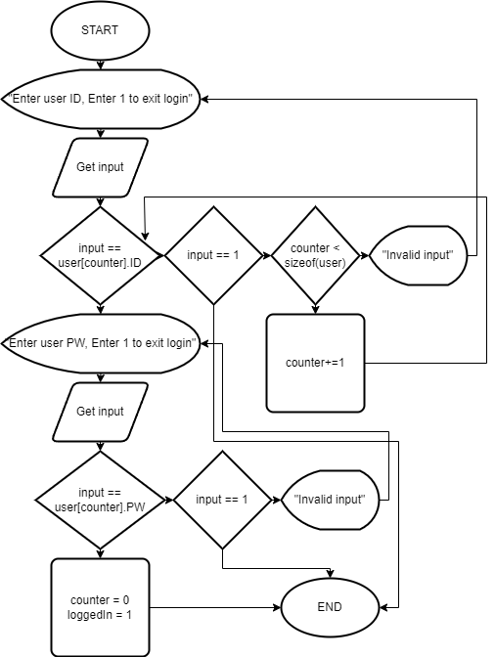

No

No

No

Yes

Yes

Yes

No

No

Yes

Yes

**FLOWCHART**

**System Process**: Add item

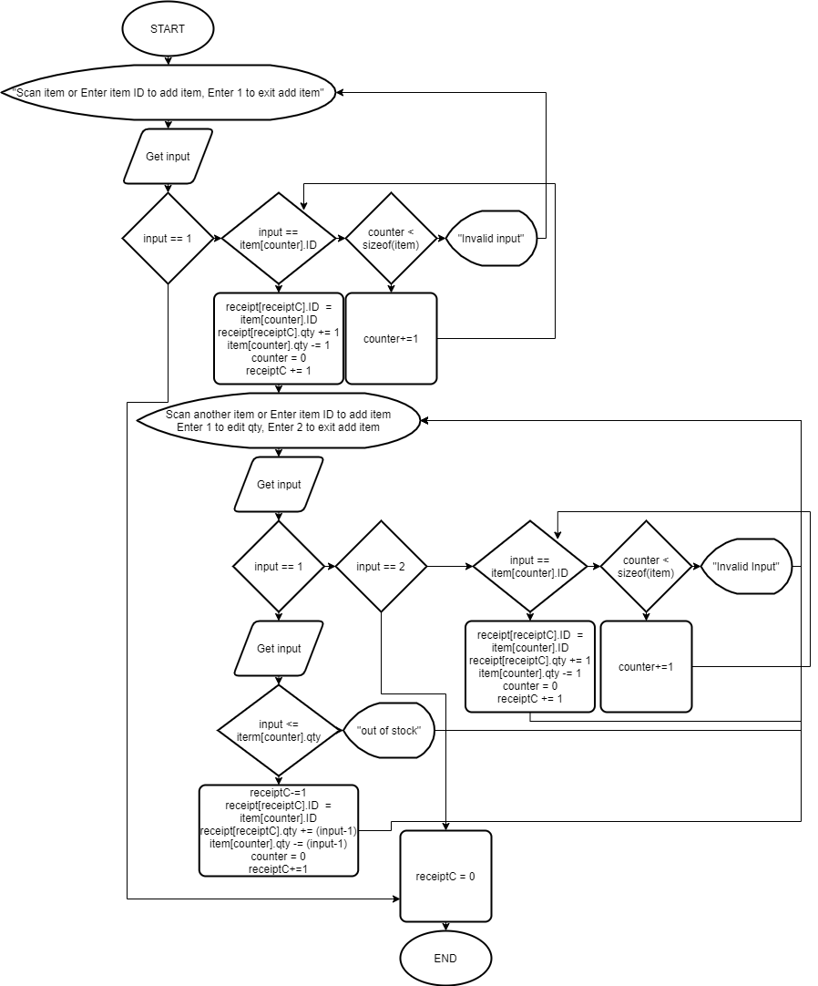

No

No

No

Yes

Yes

Yes

No

No

No

No

Yes

Yes

Yes

Yes

No

Yes

**FLOWCHART**

**System Process**: Checkout

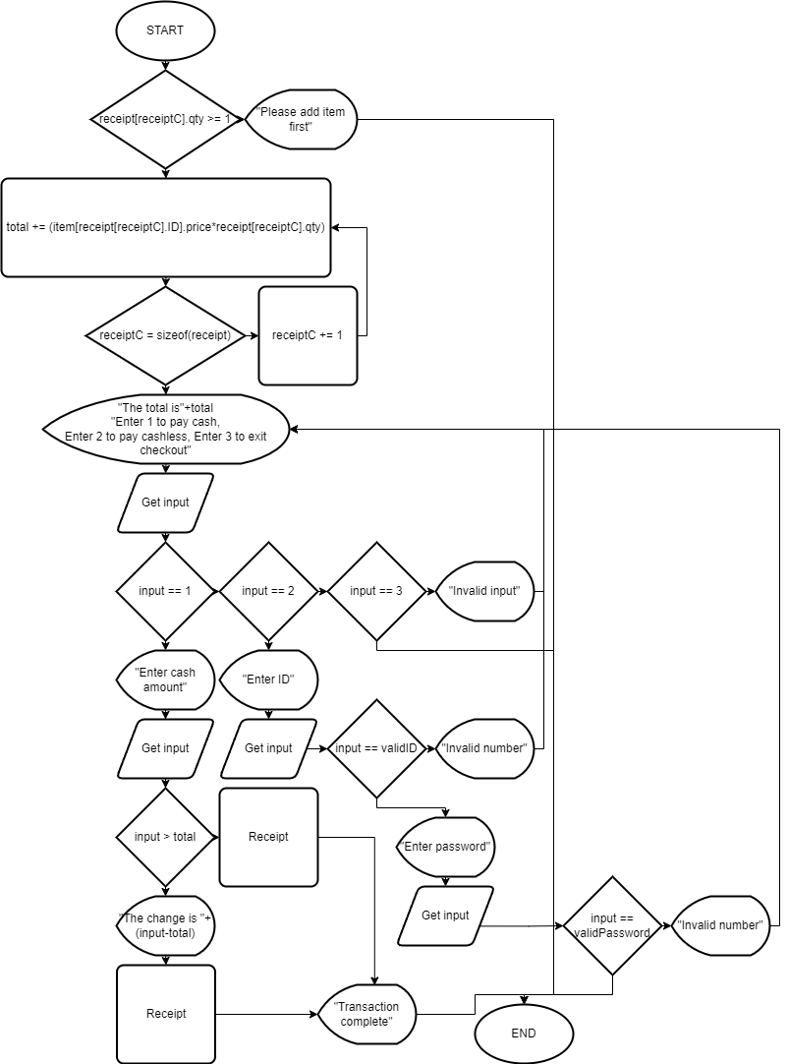

No

Yes

No

Yes

No

No

No

Yes

Yes

Yes

No

No

Yes

Yes

No

Yes

**FLOWCHART**

**System Process**: Receipt

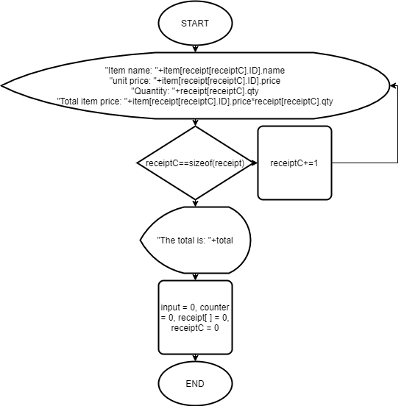

No

Yes

**PSEUDOCODE**

**System Process**: Main program

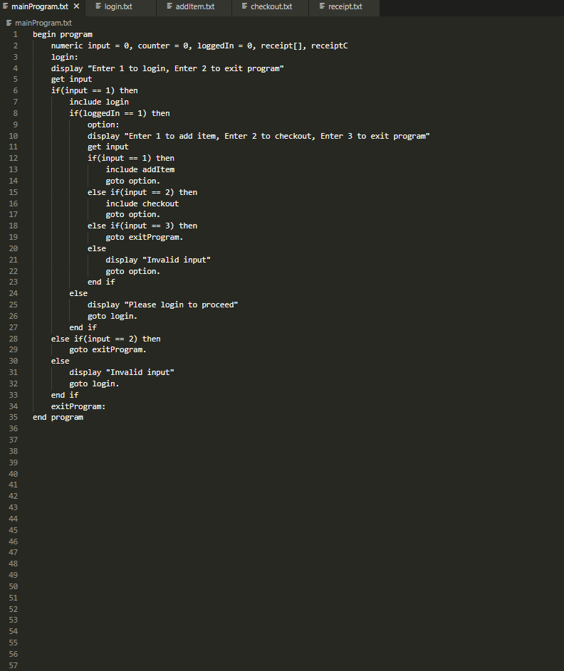

**PSEUDOCODE**

**System Process**: Login

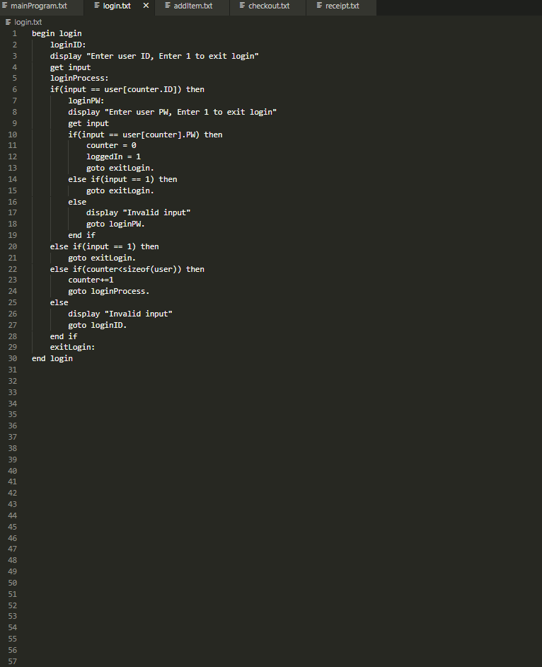

**PSEUDOCODE**

**System Process**: Add item

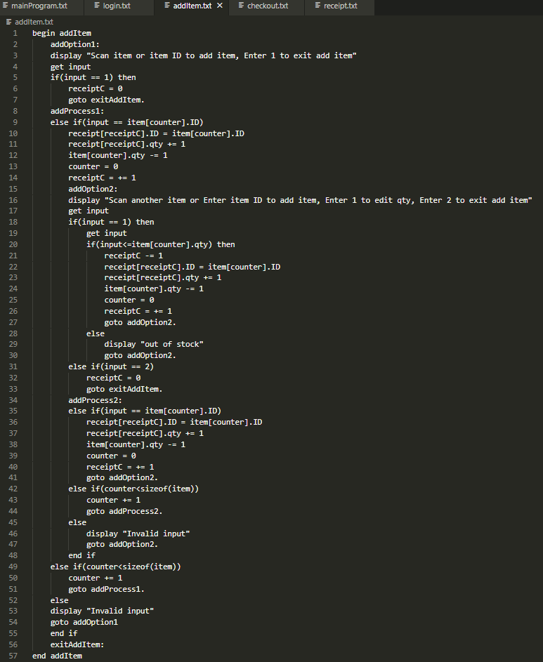

**PSEUDOCODE**

**System Process**: Checkout

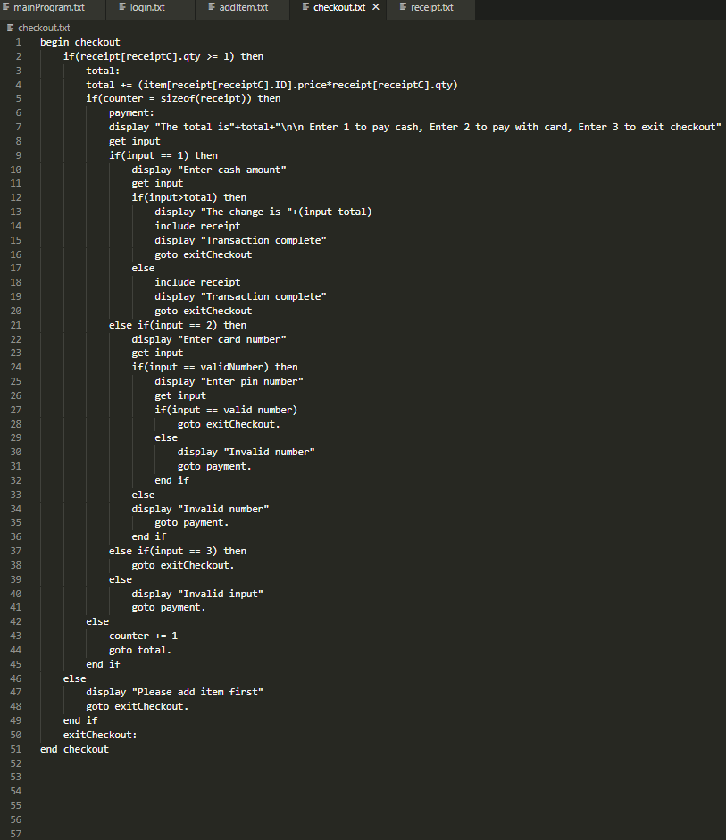

**PSEUDOCODE**

**System Process**: Receipt

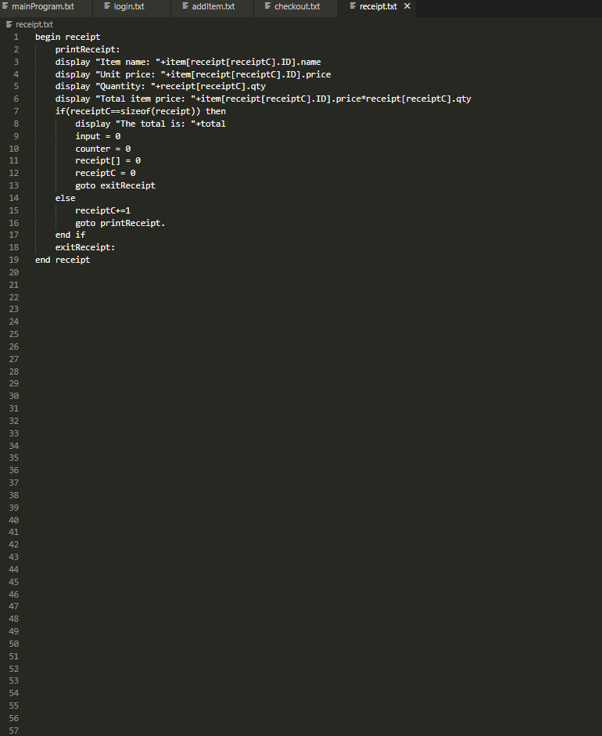

|  |  |  |  |  |
| --- | --- | --- | --- | --- |
| No | Process name | Display | Input | Output |
| 01 | Login option | Enter 1 to login, Enter 2 to exit program | 1 | Login process |
| 02 | Input user ID | Enter user ID, Enter 1 to exit login | (valid user ID) | Next login process |
| 03 | Input user PW | Enter user PW, Enter 1 to exit login | (valid user PW) | Main menu |
| 04 | Main menu | Enter 1 to add item, Enter 2 to checkout, Enter 3 to exit program | 1 | Add item process |
| 05 | Add item | Scan item or enter item ID to add item, Enter 1 to exit add item | (item ID) | Next add item process |
| 06 | Add item option | Scan another item or Enter item ID to add item, Enter 1 to edit qty, Enter 2 to exit add item | 1 | Edit item option |
| 07 | Edit item quantity |  | 2 | Next edit item process |
| 08 | Add item option | Scan another item or Enter item ID to add item, Enter 1 to edit qty, Enter 2 to exit add item | 2 | Back to main menu |
| 09 | Main menu | Enter 1 to add item, Enter 2 to checkout, Enter 3 to exit program | 2 | Checkout process |
| 10 | Payment option | The total is: Rp.25000 (Example)  Enter 1 to pay cash, Enter 2 to pay cashless, Enter 3 to exit checkout | 1 | Next checkout process |
| 11 | Input cash amount | Enter cash amount | 50000(example) | Next checkout process |
| 12 | Cash change | The change is Rp.25,000 |  | Receipt process |
| 13 | Receipt(item summary) | (example) Unit name: 1kg salt  Unit price: Rp.12,500  Quantity: 2 Total item price: Rp 25.000 |  | Next receipt process |
| 14 | Receipt(total) | The total is Rp 25,000 |  | Back to main menu |
| 15 | Main menu | Enter 1 to add item, Enter 2 to checkout, Enter 3 to exit program | 3 | Exit program |

**DRY RUN**

**CONFIGURATION**

**Hardware :** Laptop

**Operating System :**  Windows 11

**Software :**  Diagrams.net 20.5.1, Visual Studio Code 1.72.2

|  |  |  |
| --- | --- | --- |
| **PROJECT FILE DETAILS** | | |
| **S.No** | **File Name** | **Remarks** |
| 01 | mainProgramFlowchart.PNG | Main program flowchart |
| 02 | loginFlowchart.PNG | Login flowchart |
| 03 | addItemFlowchart.PNG | Add item flowchart |
| 04 | checkoutFlowchart.PNG | Checkout flowchart |
| 05 | receiptFlowchart.PNG | Receipt flowchart |
| 06 | mainProgram.txt | Main program pseudocode |
| 07 | Login.txt | Main program pseudocode |
| 08 | addItem.txt | Add item pseudo code |
| 09 | Checkout.txt | Checkout pseudocode |
| 10 | Receipt.txt | Receipt pseudocode |
| 11 | Group 3 1CC2 Project 2.docx | Papers |
| 12 | Group 3 1CC2 Project 2.PDF | Presentation slide |